1. 
2. 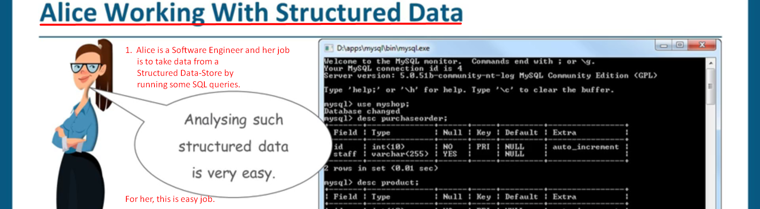
3. By looking at her work, her boss promotes her to the **Data Engineer.**Her Job is to look at the logs and help the customers with their queries.   
   
4. **Why is Log Analysis Becoming More Important? (14:35)**
5. With the evolution of technologies, there are many components (DB, Network related services etc.) attached to our app coming from different vendors.   
   Each vendor has their own patterns of logs.  
   Analyzing the logs to figure out the issue is very important.   
   **There are many scenarios where Logs can be useful like**:
   1. For Production Morning and Debugging.
   2. To find out HTTP Errors occurring in Web Server.
   3. How well queries are being performed.
   4. How many users are logged in?  
      How many users visited the app?  
      What they were/are doing? etc.

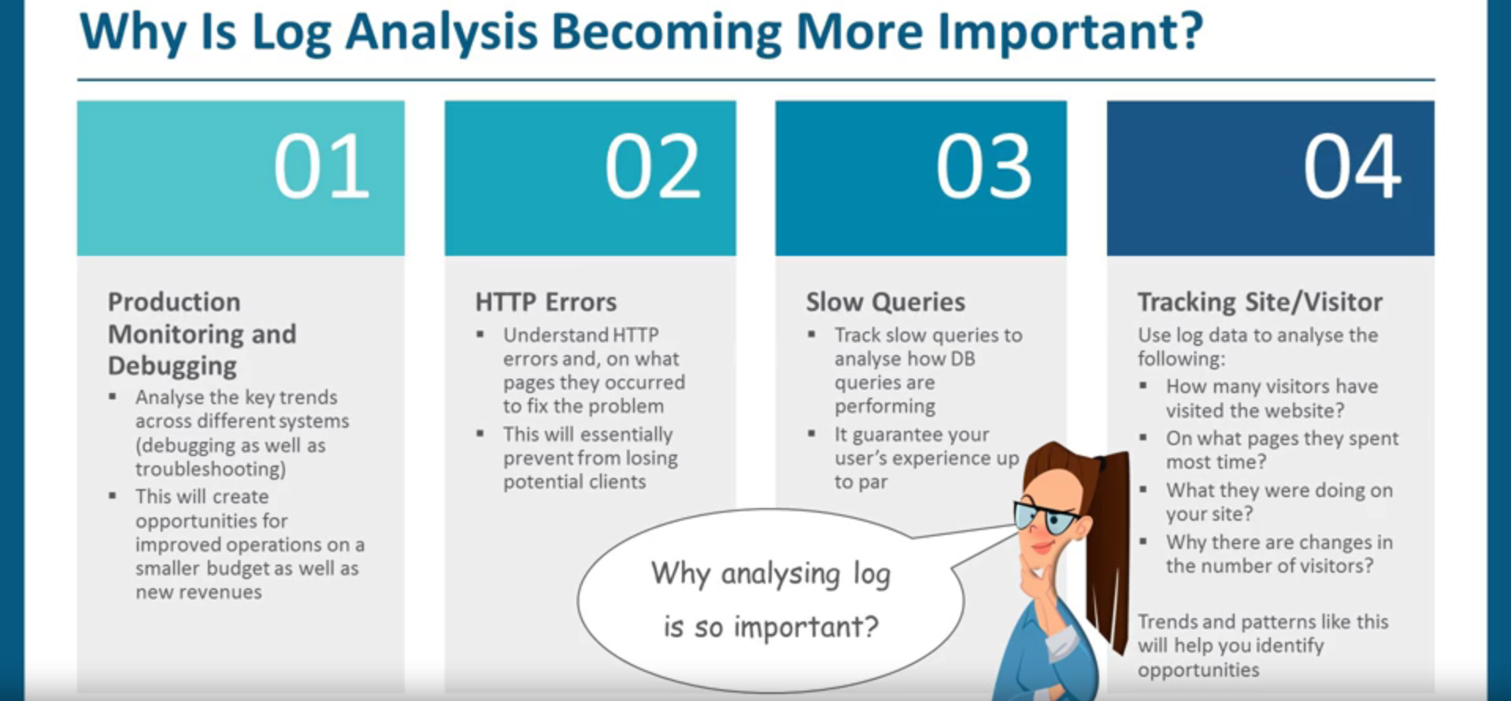

1. 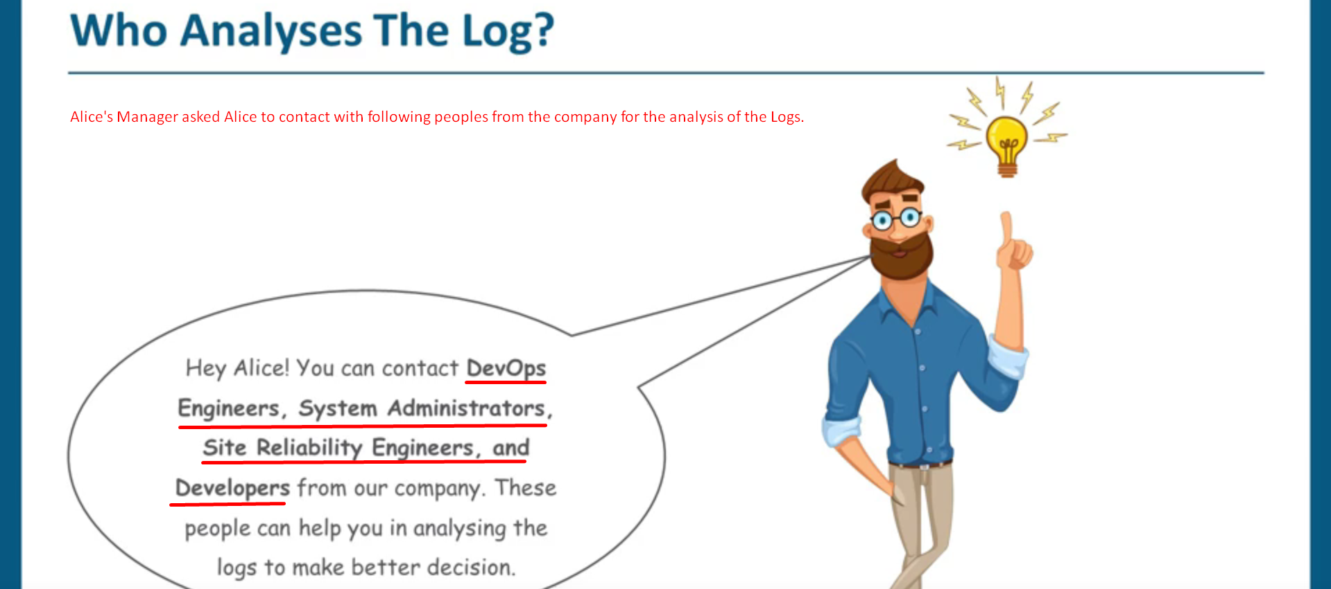
2. 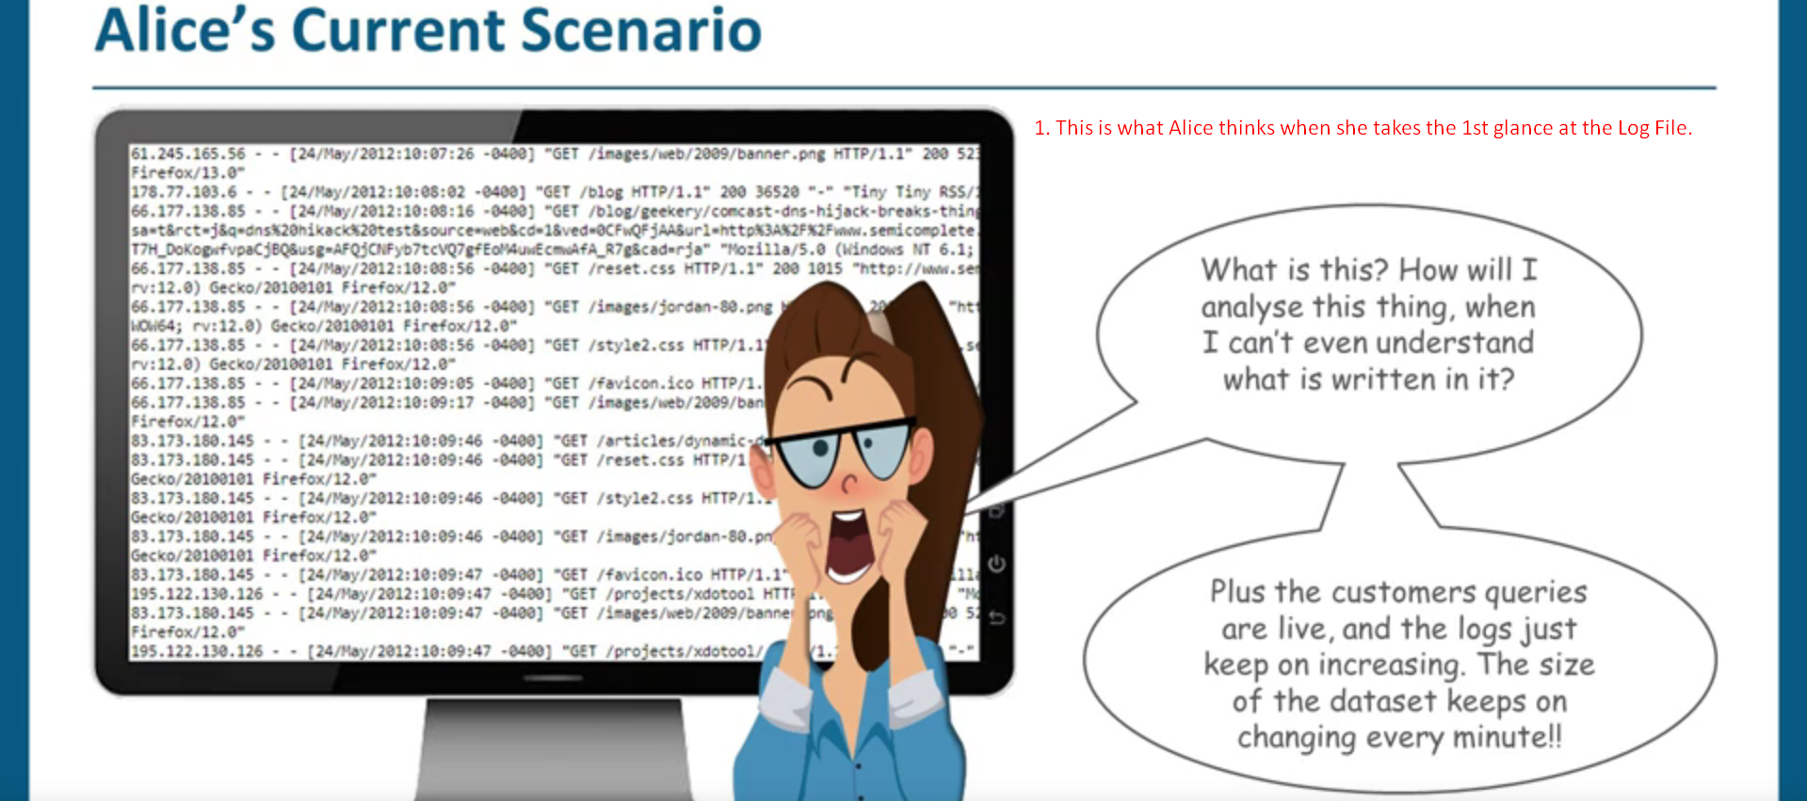
3. 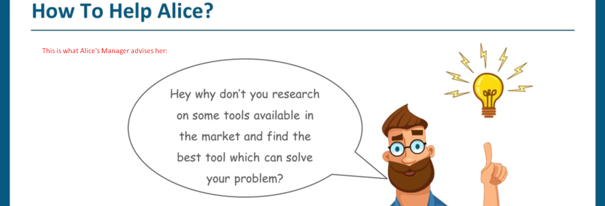
4. 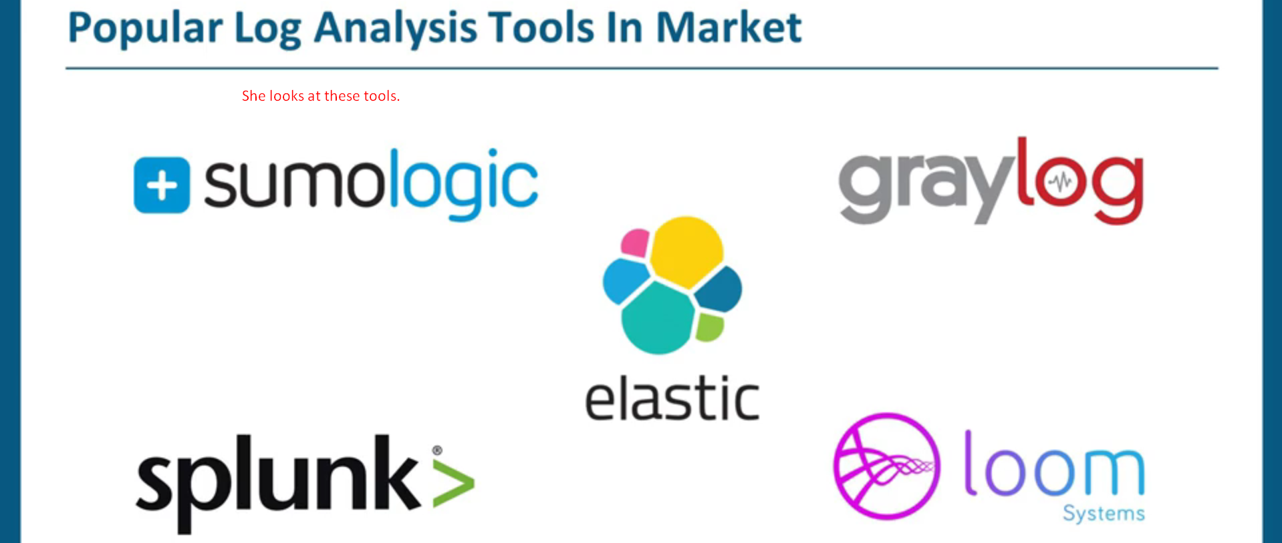
5. 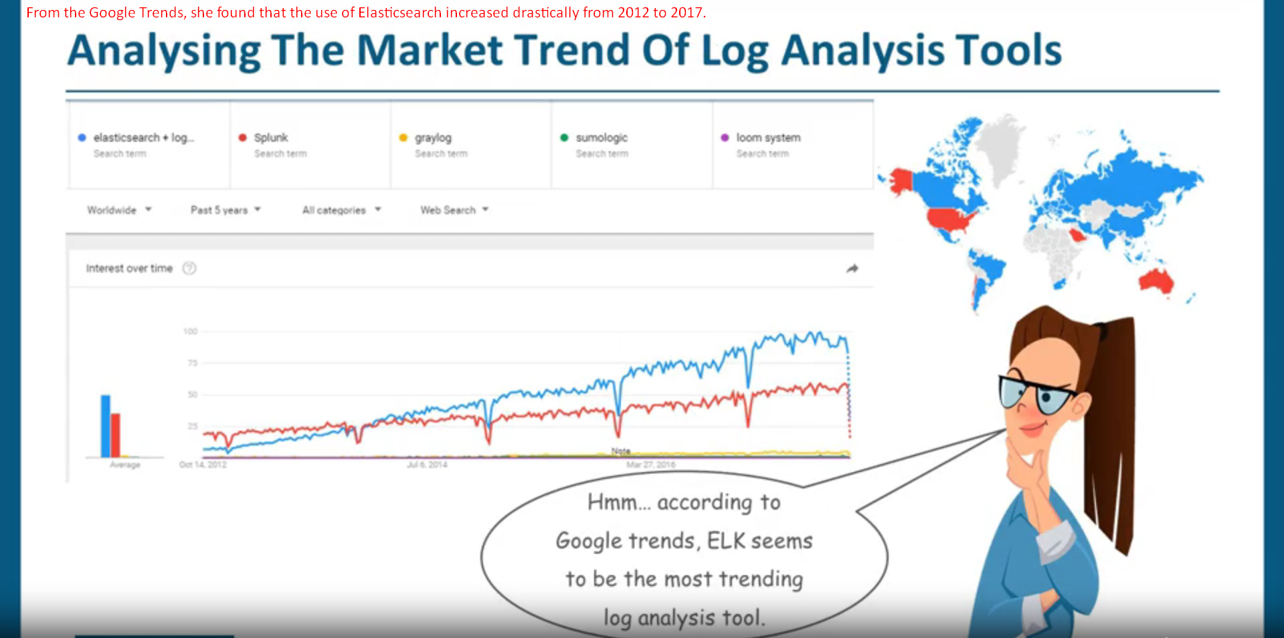
6. 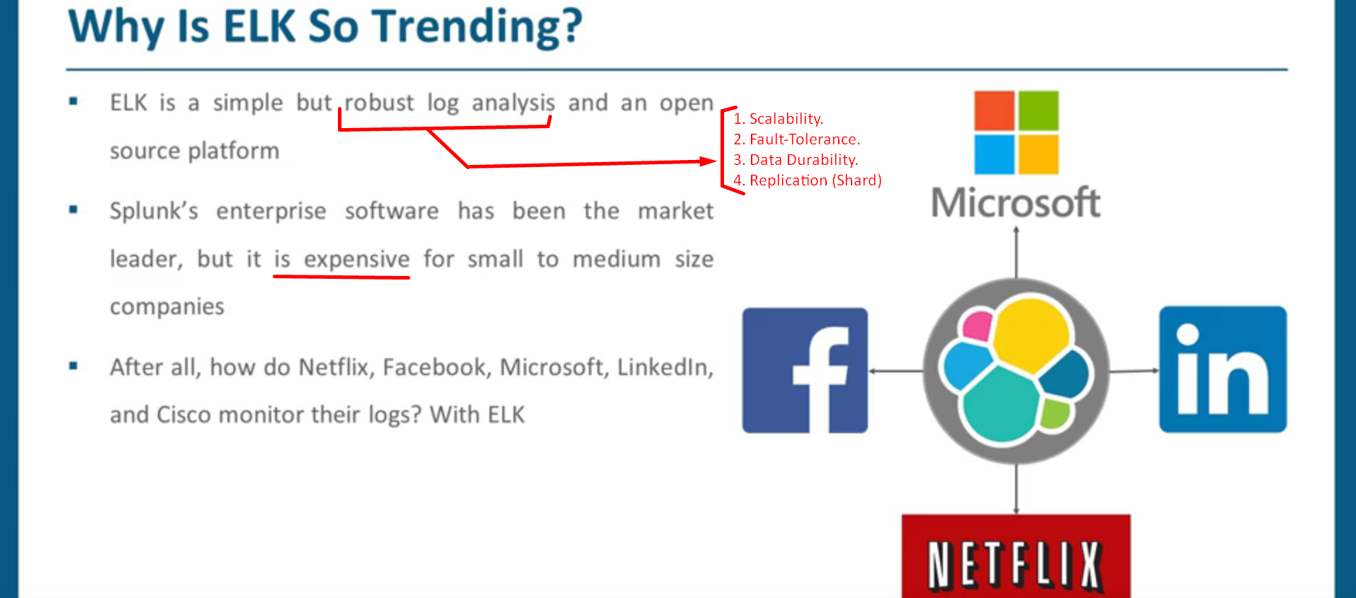
7. 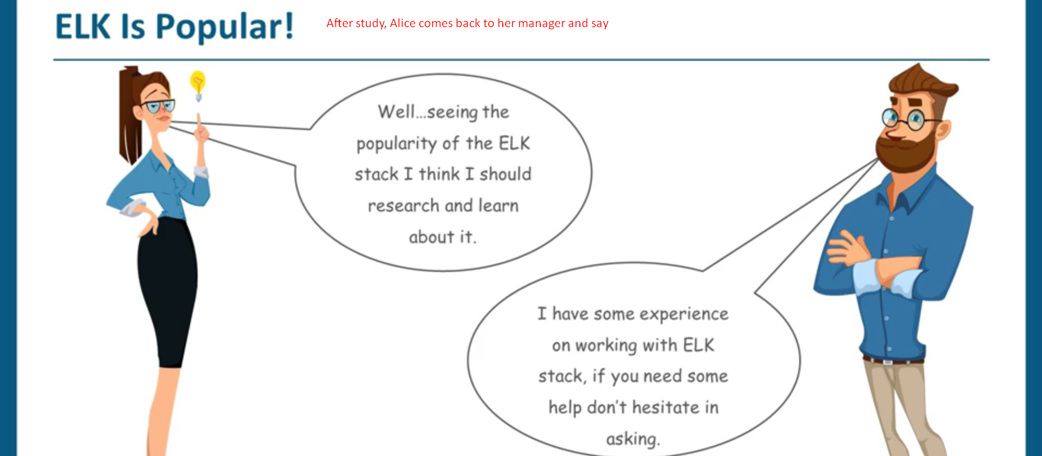
8. ELK Stack has three tools (Logstash, Elasticsearch, Kibana) and they are all different but work together.
   1. **Logstash**:
      1. Data pipeline.
      2. It fetches the data/events from a log file and puts into a destination like Elasticsearch, DB, File System, Kafka Queue etc.
   2. **Elasticsearch**:
      1. It is Core Search Engine with Data Store for logs/events.
   3. **Kibana**:
      1. UI Component to visualize the logs in charts etc.

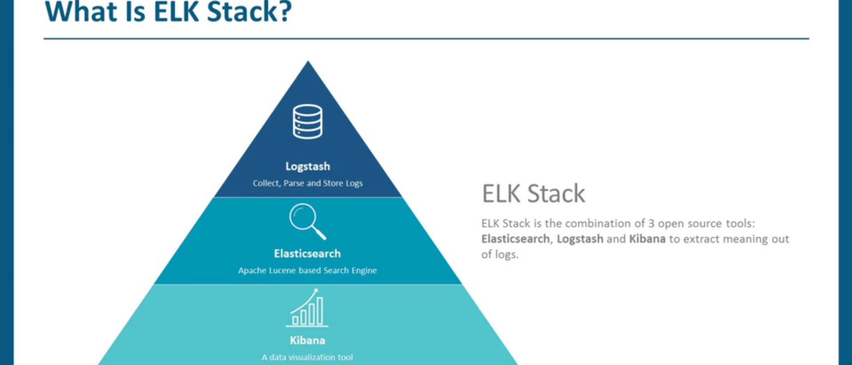

1. 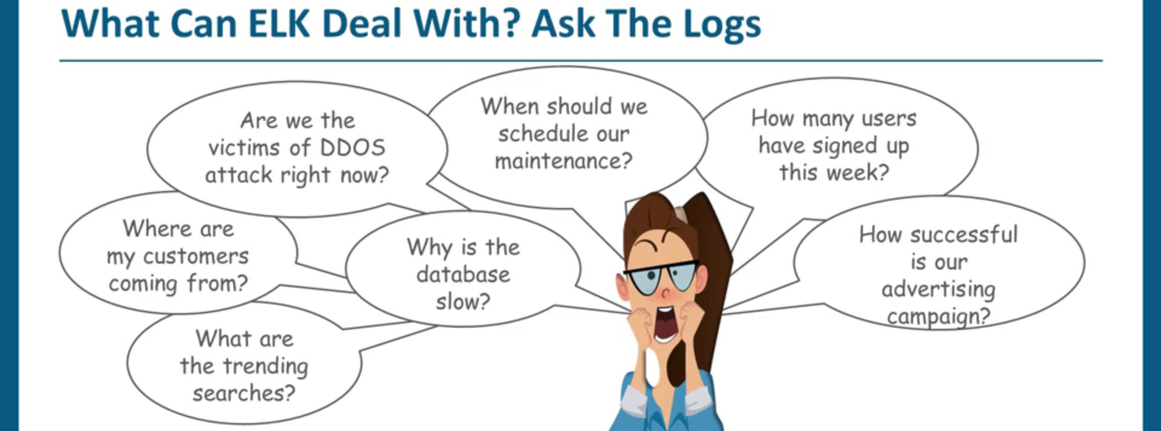
2. 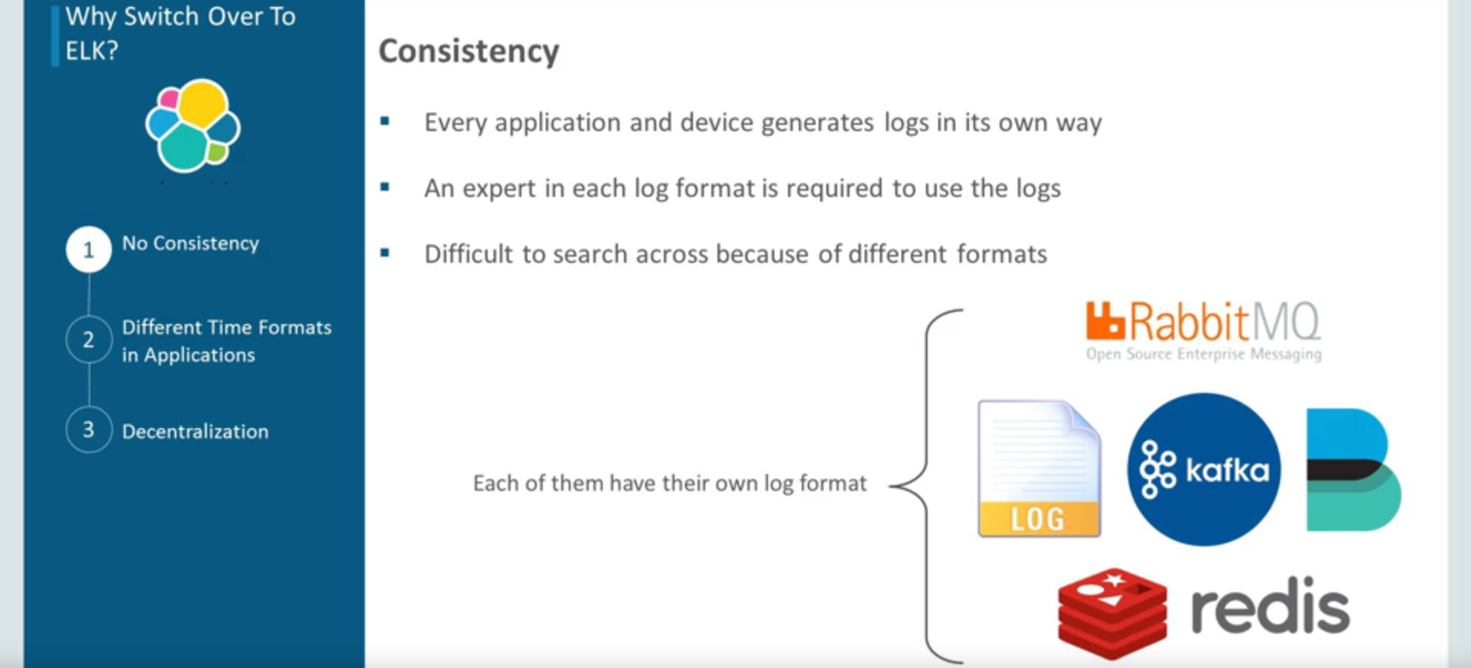
3. 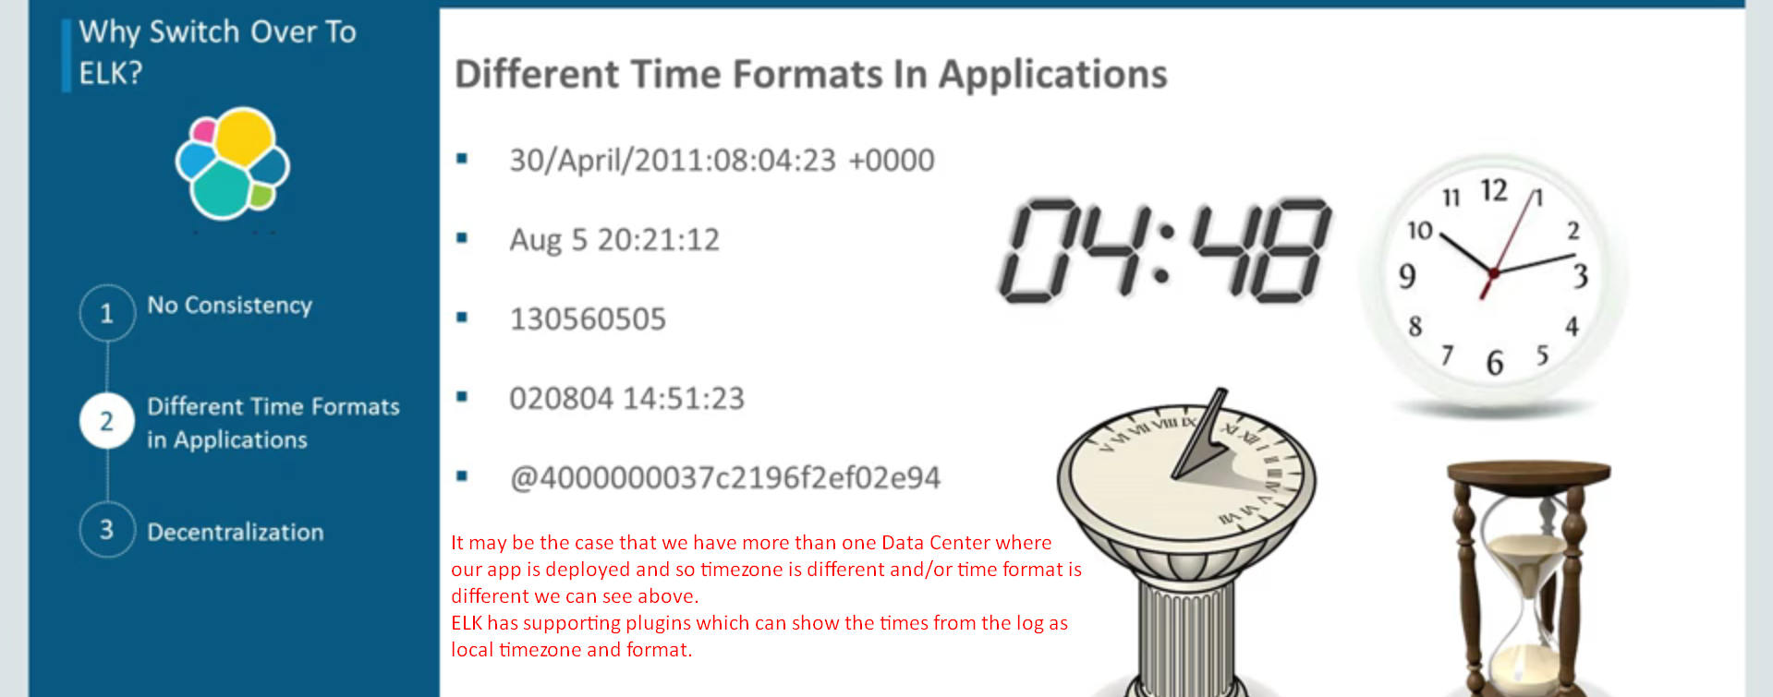
4. 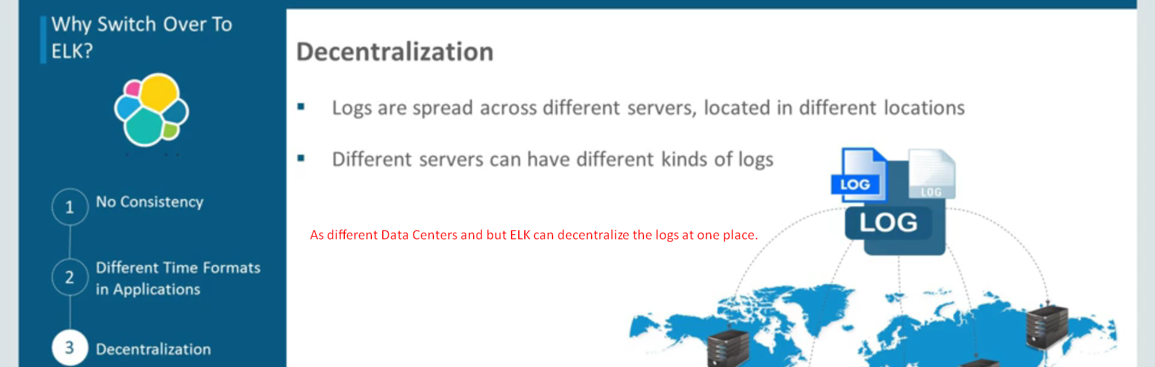
5. 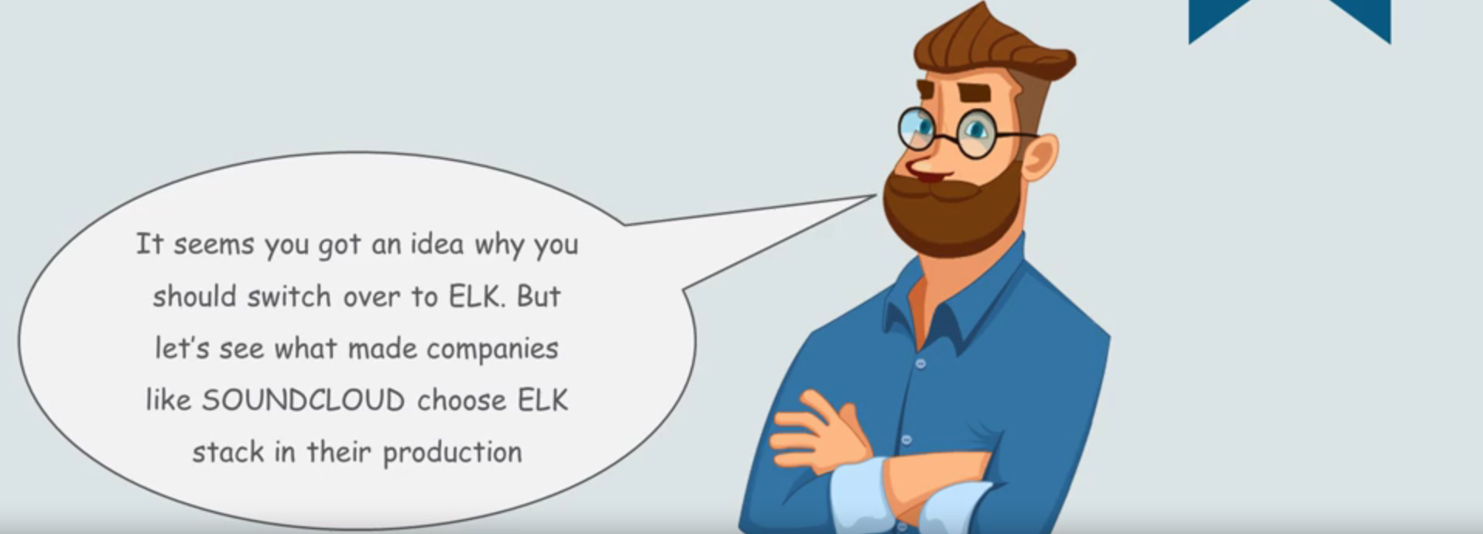
6. 
7. 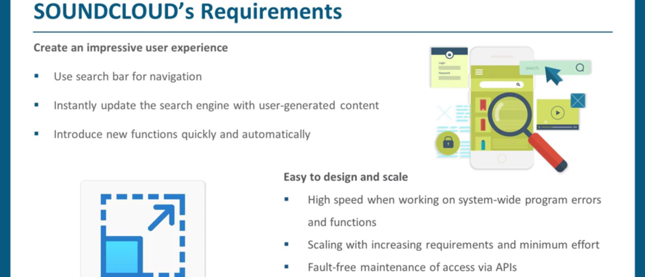
8. 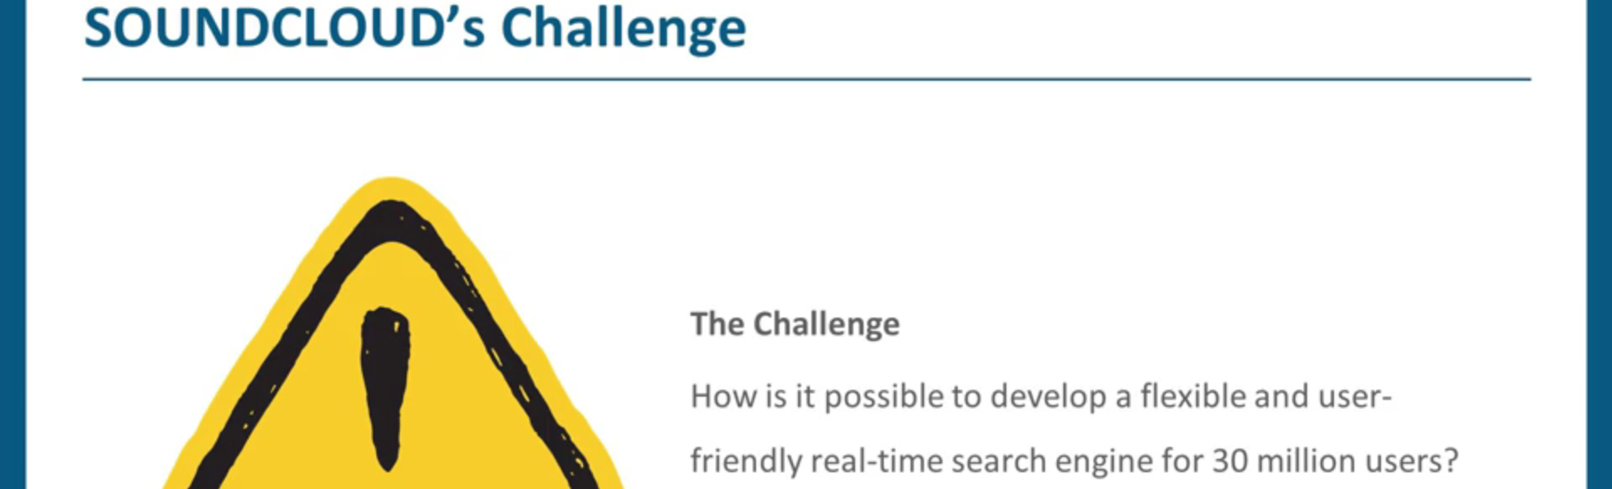
9. 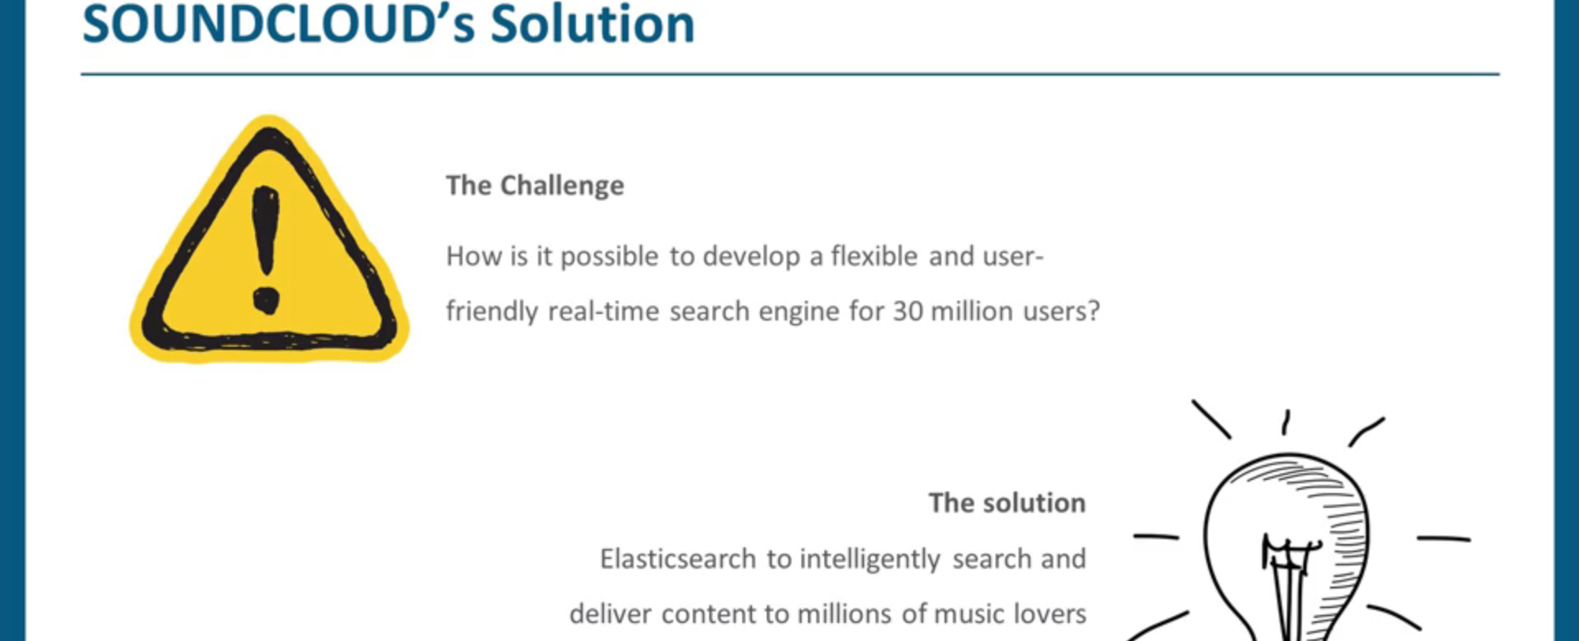
10. 
11. 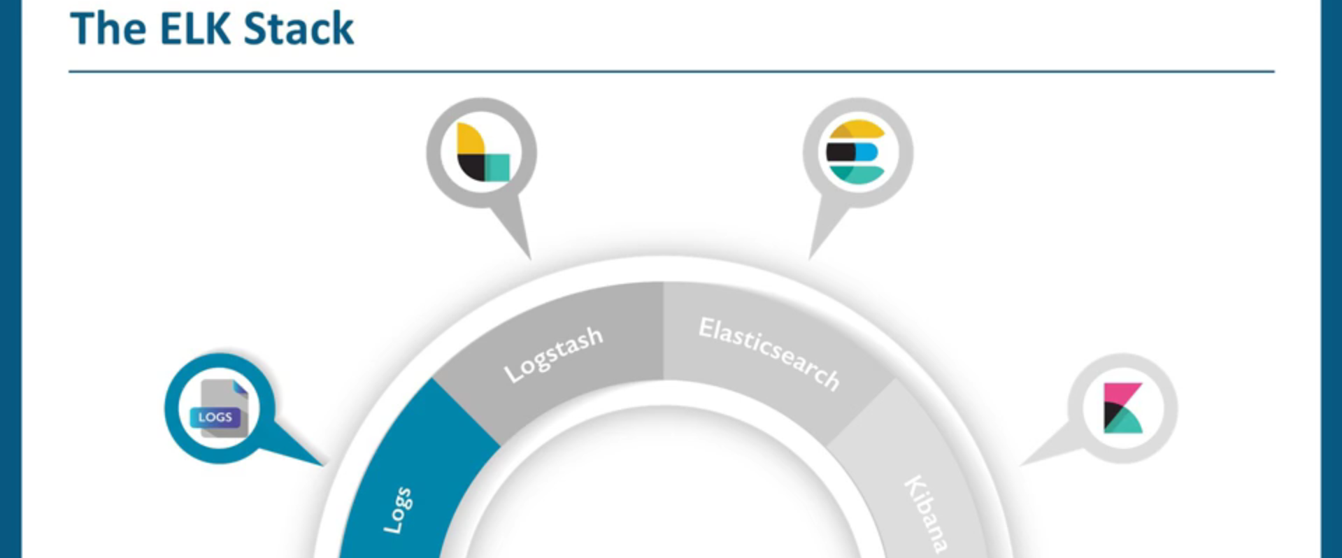
12. 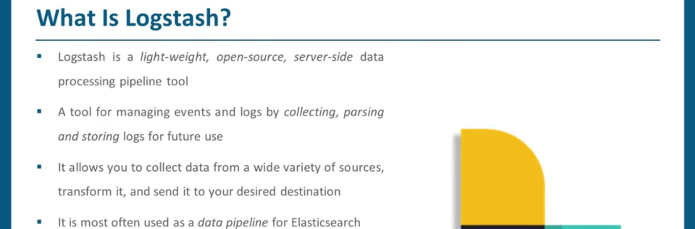
13. 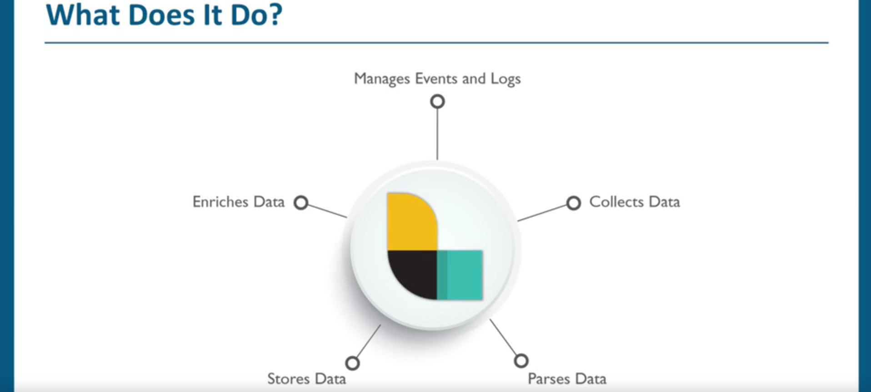
14. 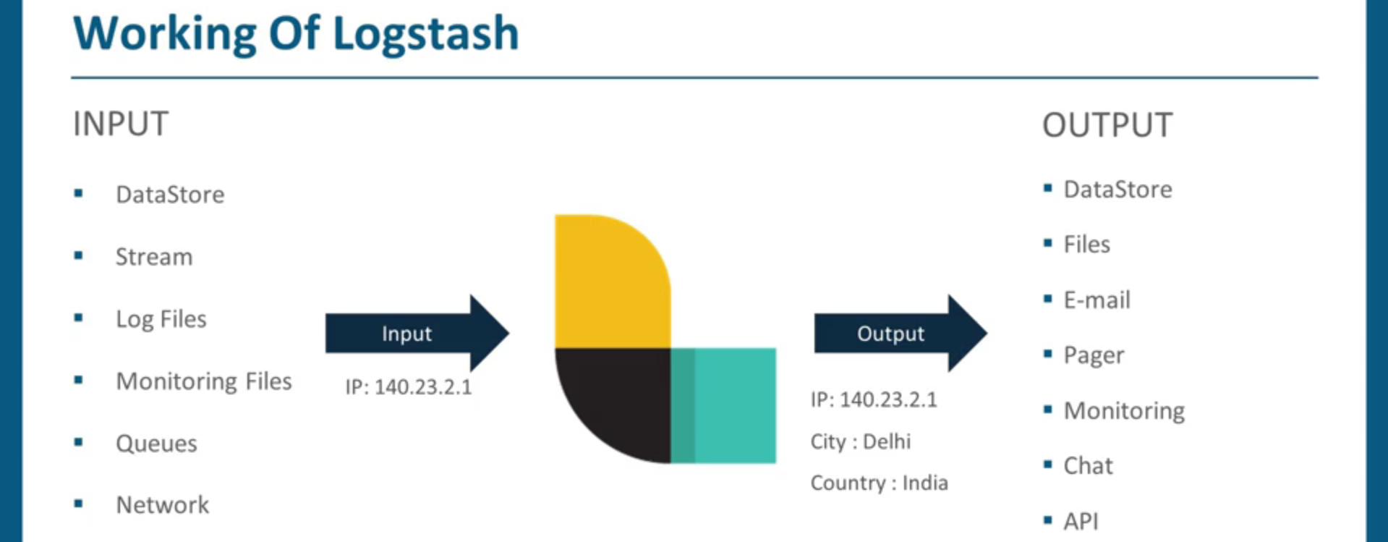
15. 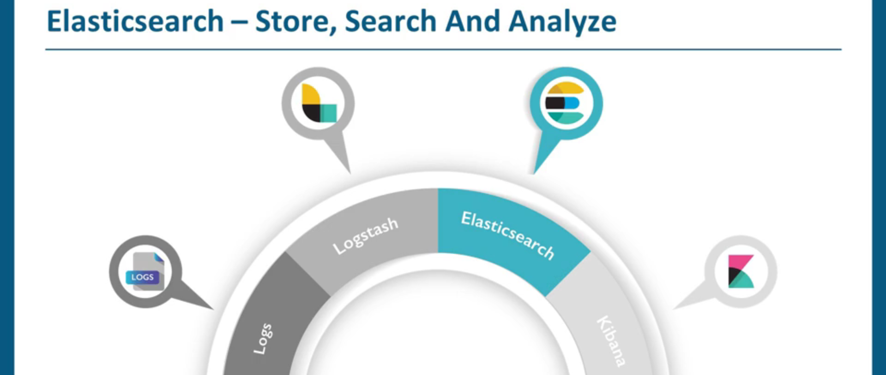
16. 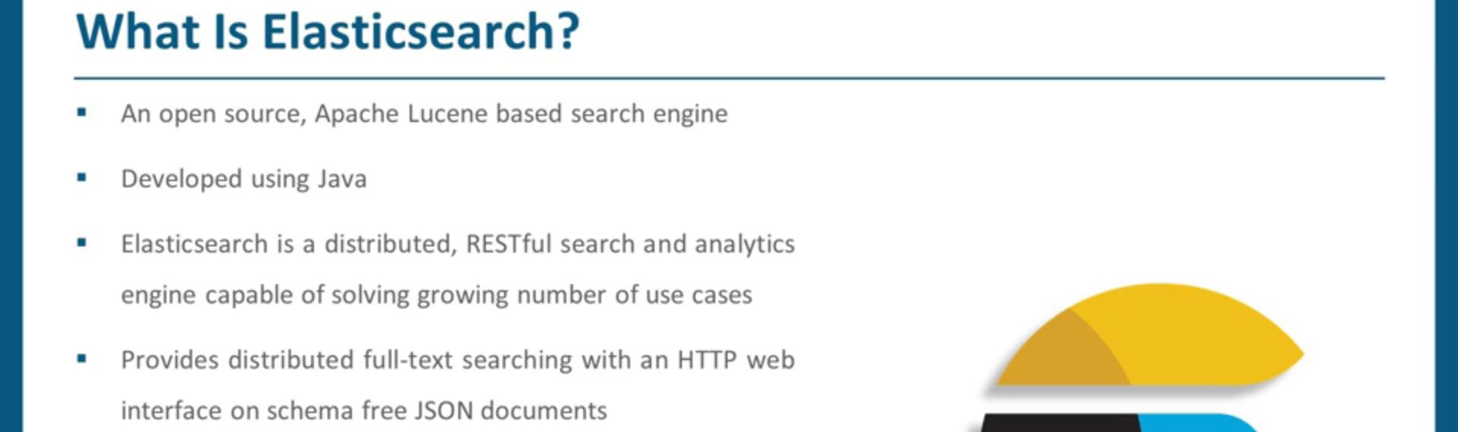
17. 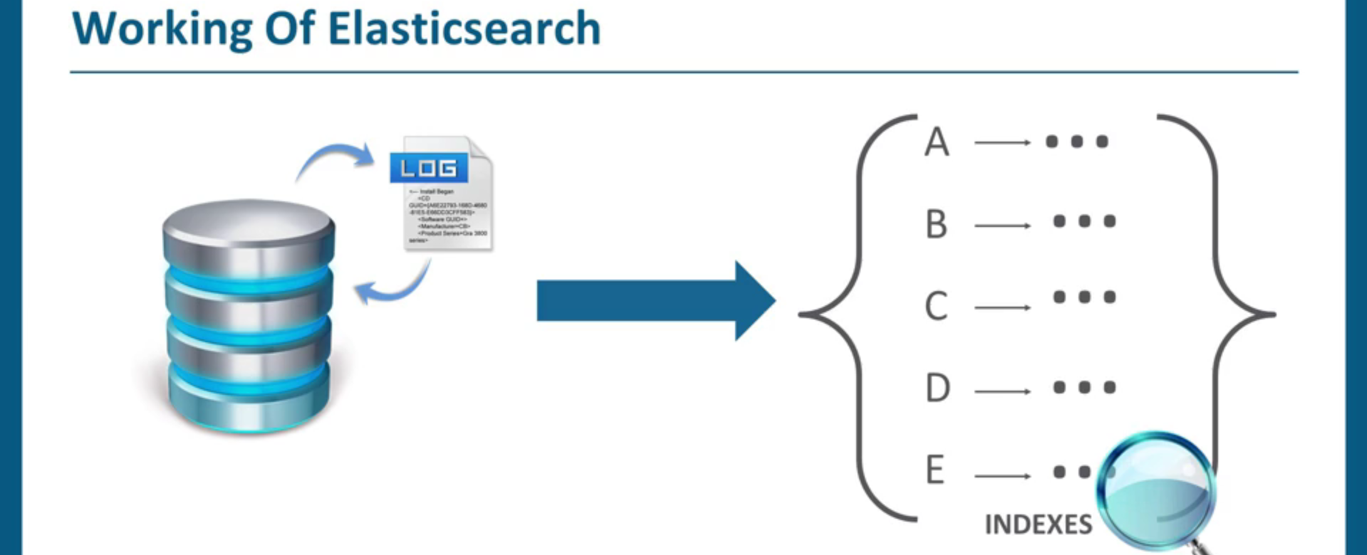
18. 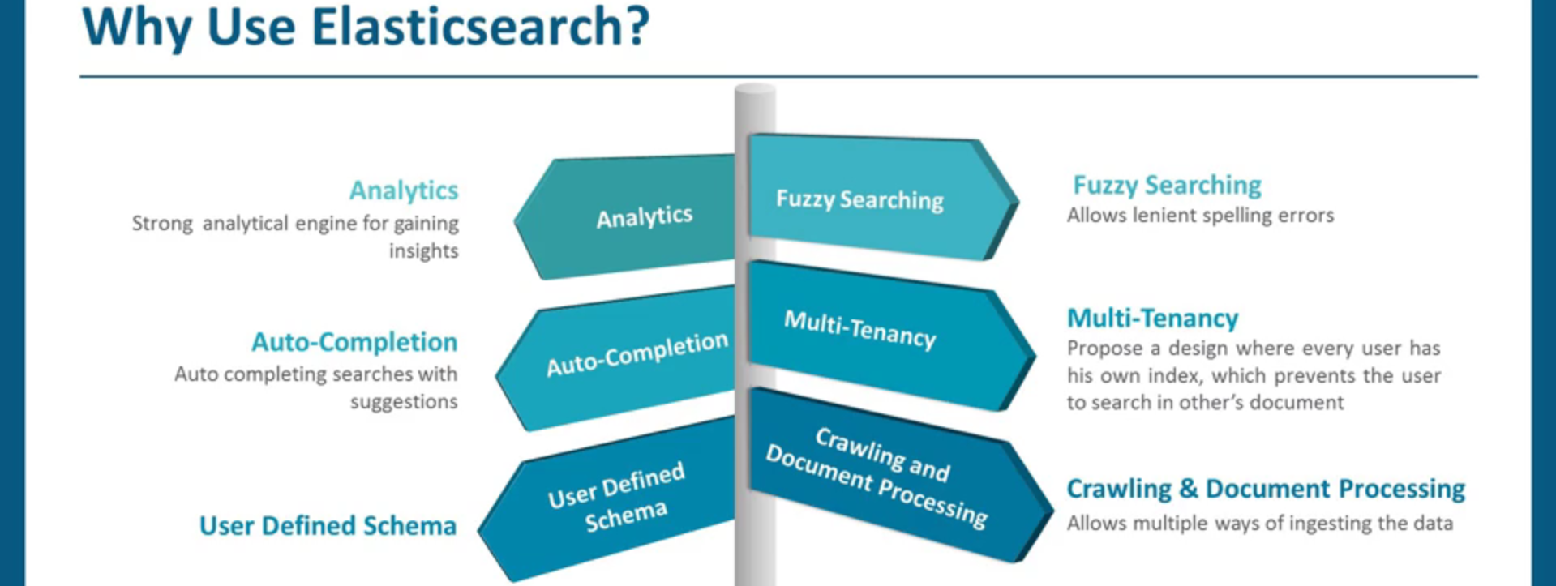
19. 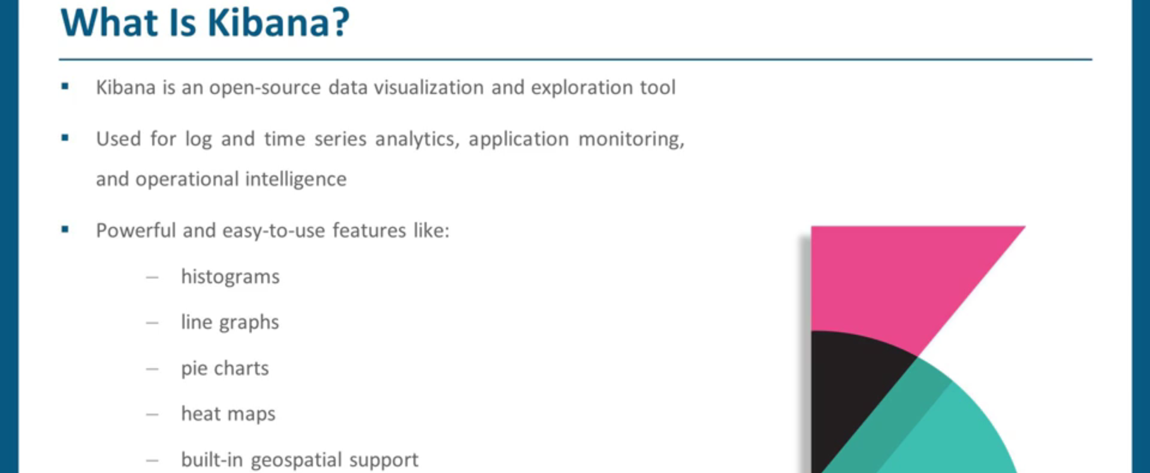
20. 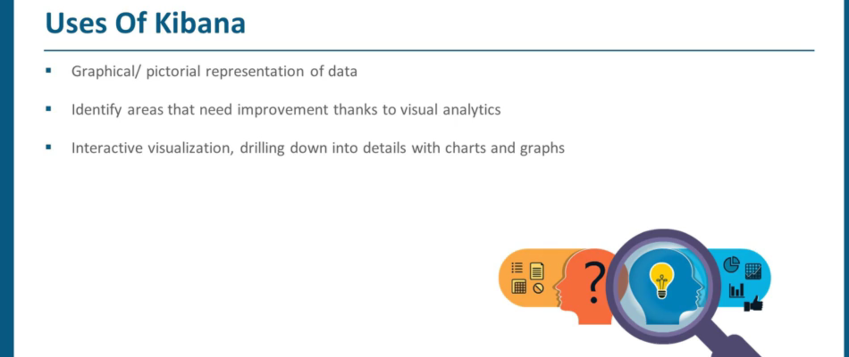
21. 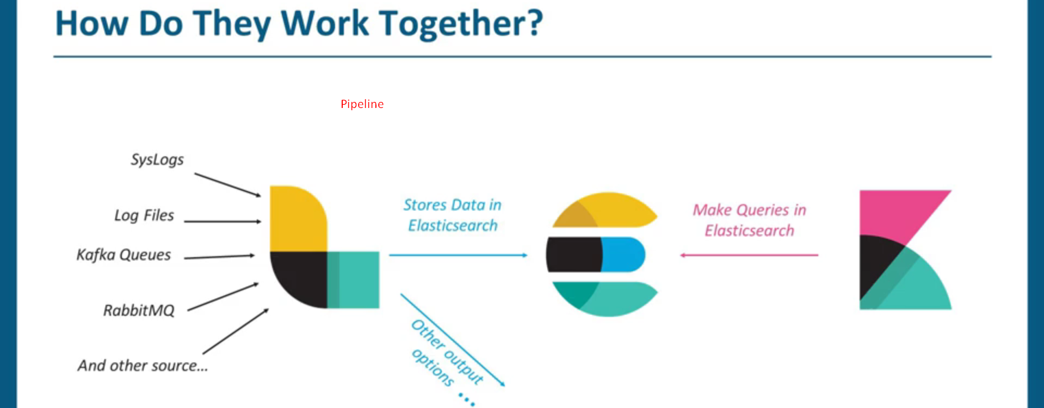
22. 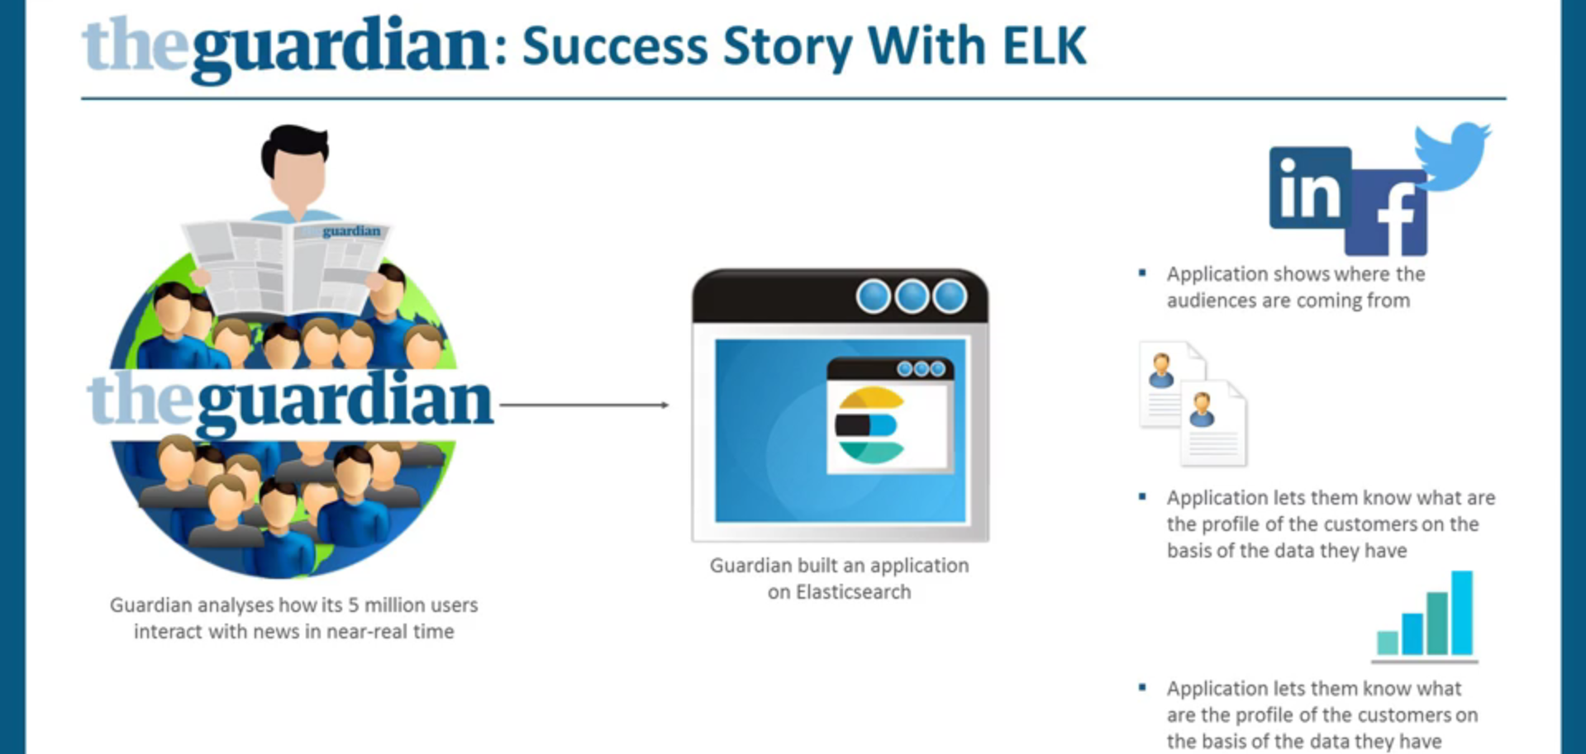
23. 
24. 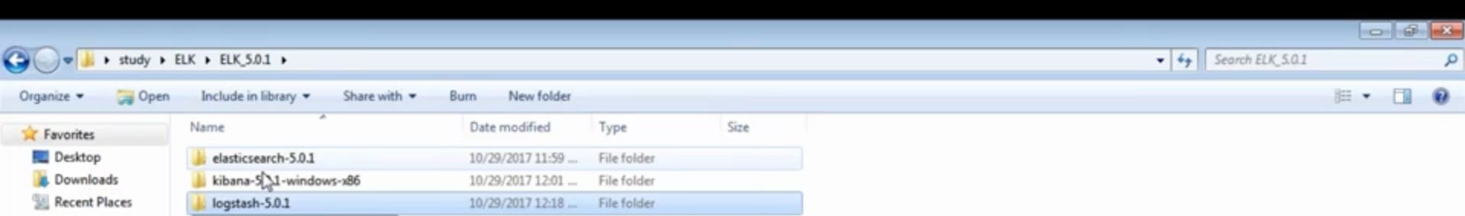
25. The instructor Gaurav give a demo of Kibana which I didn’t noted down. 😊